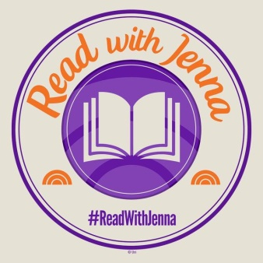
Book Nerd alert-

Read with Jenna Book Club Selections
Jenna Bush-Hager selects books on the Today Show segment monthly

2021
☐ August- “The Turnout” by Megan Abbott
☐ July- “Hell of a Book” by Jason Mott
☐ June- “Malibu Rising” by Taylor Jenkins Reid
☐ May- “Great Circle” by Maggie Shipstead
☐ April- “Good Company” by Cynthia D’Aprix
☐ March- “What’s Mine and Yours” by Naima Coster
☐ February- “Four Winds” by Kristin Hannah
☐ February- “Send For Me” by Lauren Fox
☐ January- “Black Buck” by Mateo Askaripour

2020
☐ December- “Bluest Eye” b y Toni Morrison
☐ November- “White Ivy” by Susie Yang
☐ October- “Leave the World Behind” by Rumaan Alam
☐ September- “Transcendent Kingdom” by Yaa Gyasi
☐ August- “Here For It” by R. Eric Thomas
☐ August- “The Comeback” by Ella Berman
☐ July- “Friends and Strangers” by J. Courtney Sullivan
☐ June- “A Burning” by Megha Majumdar
☐ May- “All Adults Here” by Emma Straub
☐ April- “Valentine” by Elizabeth Wetmore
☐ March- “Writers & Lovers” by Lily King
☐ February- “The Girl with the Louding Voice” by Abi Dare
☐ January- “Dear Edward” by Ann Napolitano

2019
☐ December- “Late Migrations: A Natural History of Love and Loss” by Magaret Renkl
☐ November- “Nothing To See Here” by Kevin Wilson
☐ October- “The Dutch House” by Ann Patchett
☐ September- “The Dearly Beloved” by Cara Wall
☐ August- “Patsy: by Nicole Dennis-Benn
☐ July- “Evvie Drake Starts Over” by Linda Holmes
☐ June- “Searching For Sylvie Lee” by Jean Kwok
☐ May- “A Woman Is No Man” by Etaf Rum
☐ April- “The Unwinding of the Miracle: A Memoir of Life, Death, and Everything That Comes After” by Julie Yip-Williams
☐ March- “The Last Romantics” by Tara Conklin

